USE

**Colorado Health Benefit Exchange (COHBE)**



**Create Employer Account Use Case**

**Version 1.1**

**October 18, 2012**

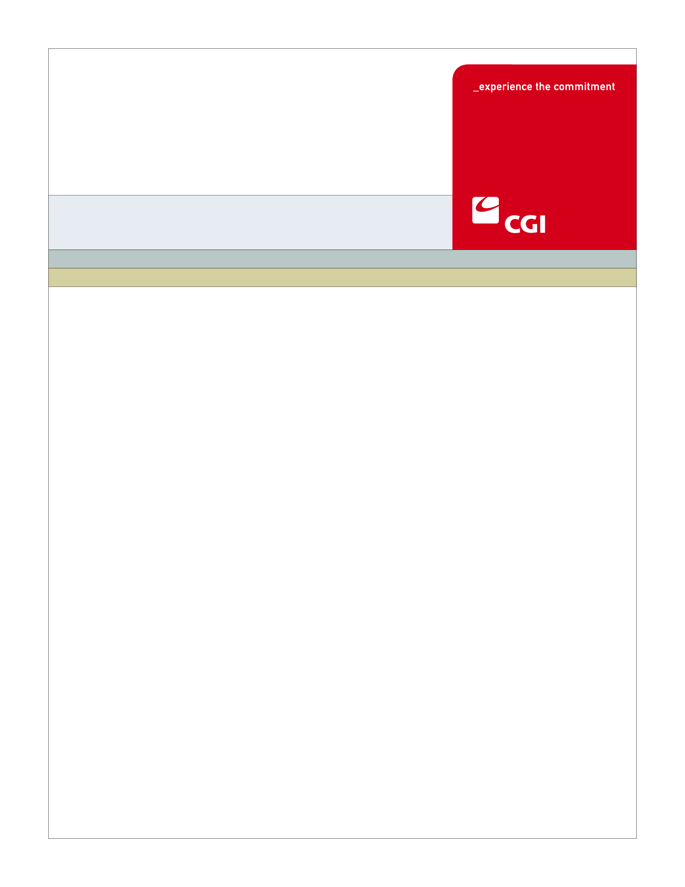

REVISION HISTORY

|  |  |  |  |
| --- | --- | --- | --- |
| Version | Date | Modified By | Description |
| 0.1 | 9/17/2012 | Diane Dunn | Initial draft for JAD Discovery Session |
| 0.2 | 9/21/2012 | Diane Dunn | Elaboration version; incorporating Discovery info |
| 0.3 | 10/3/2012 | Diane Dunn | Verification version, incorporating Elaboration info |
| 1.0 | 10/9/2012 | Diane Dunn | Final Version, incorporating Verification comments. Reviewed by Sherry Bagby for format. |
| 1.1 | 10/18/2012 | Diane Dunn | Incorporating John Barela’s comments of 10/17/12 (without UITR updates which will come later). Verbal sign off received by Rob Merry on 10/18/12. |
|  |  |  |  |
|  |  |  |  |
|  |  |  |  |
|  |  |  |  |
|  |  |  |  |
|  |  |  |  |
|  |  |  |  |
|  |  |  |  |

TABLE OF CONTENTS

1 Use Case: Create Employer Account 5

1.1 Goal 5

1.2 Brief Description 5

1.3 Requirements Traceability 5

1.4 Primary Actor 6

1.4.1 Employer 6

1.4.2 Broker 6

1.4.3 Back Office Staff 6

1.4.4 Service Representatives 6

1.4.5 Navigators 6

1.5 Secondary Actor 6

1.5.1 Exchange 6

1.6 Pre-Conditions 6

1.7 Post-Conditions 7

1.8 Triggers 8

1.9 Assumptions 8

2 Flow of Events 9

2.1 Basic (Main) Flow – Create Employer Account for New User 10

2.1.1 Register to Create an Employer Account 10

2.1.2 Enter Basic Account Information 10

2.1.3 Existing Account for Employer? 10

2.1.4 Create Account 11

2.1.5 Send Confirmation 11

2.1.6 Next Steps 11

3 Alternate Flows 11

4 Exception Flows 11

4.1 Existing Account Found for User 11

4.1.1 Prompt User to Remember Credentials 11

4.2 User Exits without Creating an Account 11

5 Specifications 12

5.1 Business Rules 12

5.1.1 Required Basic Account Information Fields 12

5.1.2 Employer Eligibility Attestation 14

5.1.3 Broker/Employer Attestation 14

5.2 Process Rules 14

5.2.1 Existing Account for User? 14

5.3 Workflow 15

5.3.1 Process Paper Employer Application 15

5.4 UI Screen Details 16

5.4.1 Employer Register Screen to be customized with Basic Information fields 16

5.5 Communications 18

5.5.1 Imaging Requirements 18

5.5.2 Form Requirements 18

5.5.3 Notices Requirements 19

5.5.4 Other Communication Requirements 19

5.6 Interfaces 19

5.6.1 No Interfaces 19

5.7 Reporting 19

5.7.1 User Experience 19

5.7.2 Business Activity 19

5.7.3 Workflow 19

5.7.4 Community and Public Health 19

5.8 User Security 20

5.8.1 Actors 20

5.8.2 Sensitive Data 20

5.9 Activity Log and Audit Trail 20

6 Future Release Notes 20

Appendix A - Glossary 20

# Use Case: Create Employer Account

## Goal

The goal of this Use Case is to successfully create an Employer Account to log into the SHOP Exchange.

This Use Case completes succesfully when the account is created and the employer has a unique user ID and password to log into the Exchange.

## Brief Description

An employer account is established on the Small Business Health Options Program (SHOP) Exchange to allow an employer to offer coverage to his/her employees. Authorized actors (broker or navigator) may also create accounts on behalf of employers.

An employer’s account must be established to allow access to features in hCentive on the SHOP Exchange. Employers will establish an account on the SHOP Exchange to setup employer sponsored plans or to manage their employee roster. Authorized actors may also create accounts on behalf of employers. After the actor accesses the register screen, basic information is entered to create an employer account. When submitted, the system checks if an account already exists in the Exchange for the business. If no existing account if found, an account is created. If the system does find an existing account, the actor is asked if they need help to proceed.

## Requirements Traceability

The following requirements are covered within this Use Case:

* GF010: There shall be two distinct URLs for customers to access the Exchange: an Individual URL (for individual households) and a SHOP URL for small employers
* GF076: Service Representatives will be able to perform all of the activities of the System on behalf of Customers, should Customers need assistance or not have access to the System. Activities of Service Representatives will be limited to the functions required by their roles.
* SH010: The System shall have a separate entry point and portal for employers conducting business on-line with the Exchange (SHOP Portal).
* SH030: Employers shall have a unique login and password.
* SH087: When setting up an Employer’s account, the Exchange shall require the employer to specify whether they were previously self-insured or not. This information shall be stored on the employer database and be available for reporting purposes. (CR‑88)
* SH127: Brokers should be allowed to access and perform similar tasks that Employers are allowed to do in the Exchange.

## Primary Actor

### Employer

An employer will enter the Exchange to create an employer account.

### Broker

Brokers logging into their broker account will create an employer account on behalf of their customer.

### Back Office Staff

Back Office staff logging into their back office account will create an employer account on behalf of the employer.

### Service Representatives

Removed for separate tracking.

### Navigators

Removed for separate tracking.

## Secondary Actor

### Exchange

The Exchange will track and store account information for users of the Exchange.

## Pre-Conditions

* Primary Actor selects SHOP Portal.
* Actors creating an account on behalf of an employer must be signed into their own account first and click on the create account button.

## Post-Conditions

* An Account will be created for the Employer with a COHBE Account Number and associated unique log in and password stored in the system
* The Determine Employer Eligibility Use Case is entered
* Account can be accessed by clicking on My Account
* Notification is sent to the Employer of the account creation
* Data created from Create Employer Account:

| Data Element |
| --- |
| Primary User Section: |
| Primary User Name (First, MI, Last) |
| COHBE Account Number |
| Unique User ID |
| Password |
| Security Questions/Answers 1, 2, and 3 |
| Company Details Section: |
| Legal Company Name |
| Name to Display in Exchange |
| Year Established |
| Federal Tax ID |
| Standard Industry Code |
| Previously Self Insured? |
| Employee Count for SHOP Exchange Eligibility |
| Legal Address of Business (no county) |
| Primary Phone |
| Secondary, Fax Phones |
| Billing Address of Business Location Section: |
| Billing Address of Business (no county) |
| Primary, Secondary, Fax Phone Numbers |
| Colorado Work Site Address of Eligible Employees Section: |
| Work Site Address of Business (includes county) |
| Primary, Secondary, Fax Phone Numbers |
| Attestations Section |
| Check box: I am a registered Broker, Navigator, or Service Representative and have the authority to act for this employer |
| Check box: I am the Employer |

## Triggers

The following events trigger this Use Case:

* An employer decides to create an employer account
* An employer is in Get Quotes (anonymous shopping), does not have an account and decides to set up plans for the employees (note: no data are retained from Get Quotes)
* A Broker enters the Broker Portal to apply for an employer client.

## Assumptions

* The hCentive system will currently only accommodate a single account/logon per business. (Other needs are addressed in Section 6.)
* All primary actors will have the same capabilities in all functional flows – therefore any reference to an Employer will apply to any of the primary actors.
* Information gathered in the Account Creation will be used in the Determine Employer Eligibility Use Case.
* Brokers will have agency agreements with employers in place before creating accounts. Paper audit trails will be needed. These will be discussed in Broker training.

# Flow of Events

The Business Process Activity diagram below shows the COHBE processes for the Create Employer Account Use Case. The steps numbered on the diagram below have detailed explanations in the sections that follow.



## Basic (Main) Flow – Create Employer Account for New User

### Register to Create an Employer Account

* Access to Create Employer Account by:
  + Employers who click the “Register” link at the top of the page while shopping.
  + Employers who click the “Register Here” on the main SHOP screen
  + Employers who click “Selected Plans” while getting quotes anonymously
  + Brokers who click on “Register Employer” on the Broker Portal
  + Service Representatives who click on “Register Employer” from within their own account

### Enter Basic Account Information

* The actor will enter the Basic Account Information.
* See Business Rules 5.1.1 for the fields on the basic information page.
* Once fields are populated, the actor clicks the “Register My Business” button
* Check boxes are displayed for the actor to check one box:
  + I am a registered Broker or Service Representative and have the authority to act for this employer
  + I am the Employer
  + I certify I am/this employer is eligible for the SHOP Exchange
    - Note: Final language on these attestations will be considered in design
* Fields are edited for completeness and validity. If any errors exist, the actor is prompted to correct them before proceeding (Business Rules 5.1.1)
* Non-employer actors, brokers, service represntatives, and back office staff should not enter the password or security questions.

### Existing Account for Employer?

The Exchange system will have the ability to check if an existing account is in the system (Process Rules, Section 5.2.1). In the basic flow, if an existing user is not found, the system will proceed to the next step 2.1.4 Create Account. If there is an existing account, the exception flow is entered at step 4.1.1, Prompt User to Remember Credentials.

### Create Account

The basic information entered will be used to create an account in the Exchange. A record will be saved to the database and a unique account number will be associated to the employer account record.

### Send Confirmation

After the account is created, the system sends a notice to the Employer confirming the account was created. The process then goes to, 2.1.6, Next Steps.

### Next Steps

At this point, the actor can proceed to:

* Maintain Employer Branding
* Manage Employee Roster
* Select Plans and Determine Contribution
* Manage Employer Information (My Account)

Once the account is created, the system will automatically proceed to:

* Determine Employer Eligibility Use Case.

# Alternate Flows

There are no alternate flows for Create Employer Account.

# Exception Flows

## Existing Account Found for User

### Prompt User to Remember Credentials

If an existing account is found to exist in the Exchange, an error will be returned to the screen saying the account exists. The user can click on Forgot Password? Or Forgot Log In? When clicked, the system proceeds to the Manage Password Use Case (AM-007).

## User Exits without Creating an Account

An actor may exit the Create Employer Account use case by choice at any time. If this happens, the actor must restart the account create process.

# Specifications

## Business Rules

### Required Basic Account Information Fields

The actor enters data for Step 2.1.2. All fields must be complete using the expected data type and format to check for an existing account (Process Rules, Section 5.2.1).

* For the Primary User:
  + First Name – Required, at least one character long
  + Middle Initial – Optional, if used, must be a letter (no numbers or special characters)
  + Last Name – Required, at least one character long
  + Email address – Optional, [name@domain.extension](mailto:name@domain.extension) format
  + Unique User ID – Required, default to email address if email has been entered, allow user to change, alpha/numeric with special characters allowed
  + Communication Preference: Email or Legal Address – Required, from a drop down list, default to Email
  + Preferred Language: English or Spanish – Required, from a drop down list, default to English
  + Password – Required for employer not shown for non-employer actors, will follow specific password security properties defined in password security properties deliverable
  + Security Question 1 – Required for employer not shown for non-employer actors, chosen from a list of several questions
  + Security Answer 1 -- Required for employer not shown for non-employer actors
  + Security Question 2 – Required for employer not shown for non-employer actors, chosen from a list of several questions and different from Question 1
  + Security Answer 2 – Required for employer not shown for non-employer actors
  + Security Question 3 – Required for employer not shown for non-employer actors, chosen from a list of several questions and different from Questions 1 and 2
  + Security Answer 3 -- Required for employer not shown for non-employer actors
* For Company Details:
  + Legal Company Name – Required, at least one character, number, or special character, allow for multiple words, embedded spaces
  + Name to Display in Exchange – Required, defaulted to Legal Name, allow name to be changed manually, at least one character or number, allow for multiple words, embedded spaces
  + Year Established – Optional, valid year after 1700 through this year
  + Was business previously self-insured? -- Required, yes or no
  + Federal Tax ID – Required, 99-9999999 structure
  + Standard Industry Code -- Required
  + Employee Count for SHOP Exchange Eligibility – Required, greater than or equal to 1, less than or equal to 50 until 1/1/16, less than or equal to 100 if after 1/1/16, will require a tool tip and link for calculation help
  + Employee Count Accurate Attestation -- Required
* For Legal Address of Business Location:
  + Address Line 1 – Required, combination of letters, numbers, and special characters, longer than one in length
  + Address Line 2 – Optional, if filled in, combination of letters, numbers, and special characters
  + City – Required, no numbers or special characters
  + Postal Code – Required, numbers or letters
  + State – Required, valid state or province
  + Primary Phone Number – Required, 999-999-9999
  + Secondary Phone Number – Optional, 999-999-9999
  + Fax Phone Number -- Optional, 999-999-9999
* For Billing Address of Business Location: (Check Box to populate if same as Legal Address)
  + Address Line 1 – Required, combination of letters, numbers, and special characters, longer than one in length
  + Address Line 2 – Optional, if filled in, combination of letters, numbers, and special characters
  + City – Required, no numbers or special characters
  + Postal Code – Required, numbers or letters
  + State – Required, valid state or province
  + Primary Phone Number – Optional, 999-999-9999
  + Secondary Phone Number – Optional, 999-999-9999
  + Fax Phone Number -- Optional, 999-999-9999
* For Colorado Work Site Address of Eligible Employees: (Check Box to populate if same as Legal Address)
  + Address Line 1 – Required, combination of letters, numbers, and special characters, longer than one in length
  + Address Line 2 – Optional, if filled in, combination of letters, numbers, and special characters
  + City – Required, no numbers or special characters
  + Zip Code – Required, numbers or letters
  + County – Required, from drop down list, must be a valid Colorado county, may change the county that is auto-populated with zip code; if changed do not revert
  + State – Required, must be CO
  + Primary Phone Number – Optional, 999-999-9999
  + Secondary Phone Number – Optional, 999-999-9999
  + Fax Phone Number -- Optional, 999-999-9999
* Check boxes on the screen to provide attestations – at least one of the following attestations must be checked (along with the agreement for the Terms of Service) before proceeding:
  + I am a registered Broker or Service Representative and have the authority to act for this employer
  + I am the Employer
  + I certify I am/this employer is eligible for the SHOP Exchange
    - Note: Final language on these attestations will be considered in design.

### Employer Eligibility Attestation

If the user does not check the employer eligibility attestation, an error will be generated and prompt the user to check the box to attest to the eligibility.

### Broker/Employer Attestation

The check box for the user creating the account must be checked attesting to the authority to create the account.

## Process Rules

### Existing Account for User?

Step 2.1.3 will check for an existing account associated with the user based on the basic information fields. The check will be performed to confirm:

* Existing Unique Login ID

Existing Employer Identification Number (EIN)

## Workflow

### Process Paper Employer Application

* Task Name: Process Paper Employer Application
* Worklist Name: Create Employer Acccount from Mail/Fax Application
* Task Type: Back Office Staff Normal Worklist
* Sort Criteria: FIFO
* SLA Watch: Five days from date of receipt
* SLA Warning: Seven days from date of receipt
* Escalation: At five days, send email to Back Office staff supervisor
* Escalation Worklist: Create Employer Account from Mail Application Escalation Worklist
* Task Actions:
  + Review Mail Application for completeness
  + Validate user account does not already exist in the Exchange
  + Scan application document
  + Scanned Applications become work items to be processed by Back Office Staff
  + Back Office Staff with the appropriate security role creates individual accounts for the items in their worklist
  + Generate welcome letter that includes the COHBE Account Number, log in ID and request a call to the Service Center for the account to be unblocked.
  + See Section 5.5.4 Other Communication Requirements for the Service Representative tasks
  + Continue to next task in the work queue

## UI Screen Details

### Employer Register Screen to be customized with Basic Information fields

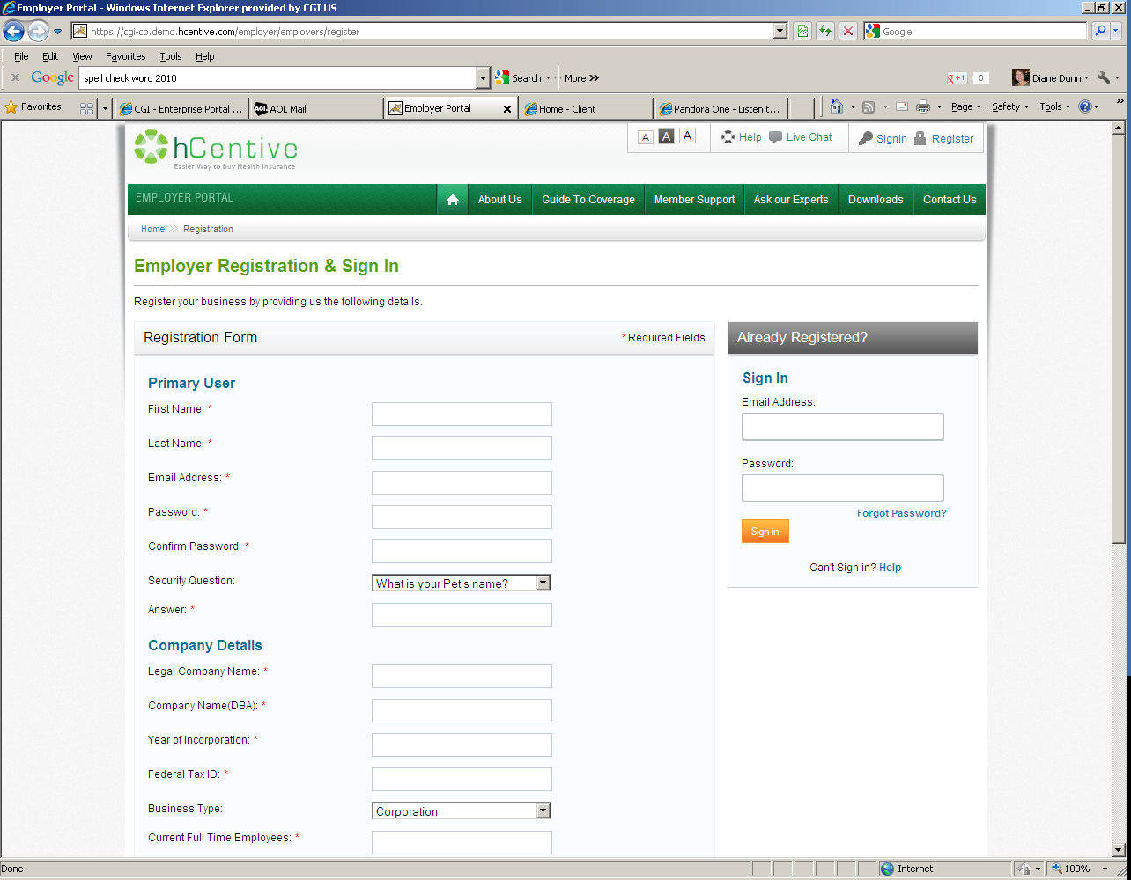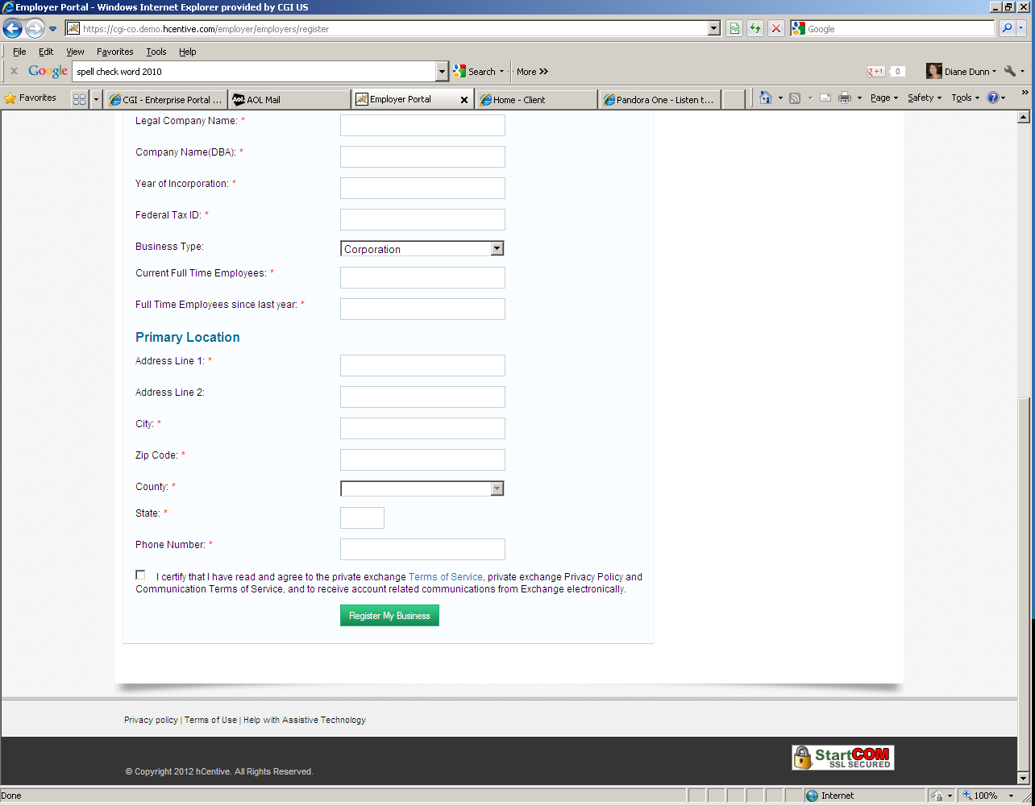

See Section 5.1.1 Business Rules as to which fields are required (denoted on screen by *) and which are optional (no asterisk).

Fields to be added to this screen are:

* In Primary User section
  + Middle Initial
  + Login Identifier
  + Communication Preference
  + Preferred Language
  + Additional Security Questions/Answers (question and answers set 2 and 3)
* In Legal Address of Business area
  + Was business previously self-insured?
  + Secondary Phone Number
  + Fax Phone Number
* Billing Address of Business
  + Address Line 1
  + Address Line 2
  + City
  + Postal Code
  + State
  + Primary Phone Number
  + Secondary Phone Number
  + Fax Phone Number
* Colorado Work Site Address of Eligible Employees:
  + Address Line 1
  + Address Line 2
  + City
  + Zip Code
  + County
  + State
  + Primary Phone Number
  + Secondary Phone Number
  + Fax Phone Number
* Check boxes with each of the following attestations:
  + I am a registered Broker, Navigator, or Service Representative and have the authority to act for this employer
  + I am the Employer

Fields to be modified on this screen are:

* Change from Company Name (DBA) to Display Name in Exchange
* Change from Year Incorporated to Year Established
* Change from Business Type to Standard Industry Code; change associated drop down list to a look up list
* Change Full Time Employees since last year to Employee Count for SHOP Exchange Eligibility
* Change Primary Location to Legal Address of Business
* Change Phone Number in Legal Address of Business to Primary Phone
* Change Zip Code in Legal Address to Postal Code

Field recommended for deletion on this screen is:

* In Legal Address of Business area, remove County
* Current Full Time Employees

Add Screen Tips to fields (to be determined in design)

* Password Field
* Employee Count for SHOP Exchange Eligibility – Need to communicate to employers how to count employees both full time and part time; This could include a tool tip or text next to the field
* Other fields to be determined during design

## Communications

### Imaging Requirements

Mail applications will be accepted for Employers. Applications will need to be imaged.

### Form Requirements

Employer Application forms will need to be developed.

### Notices Requirements

* For all employer accounts with an email, a notice will be sent advising the employer an account was created for the business. If this was not authorized by them, they will be given a number to contact for assistance.
* For all employer accounts without an email which are created by a method other than the Worklist in Section 5.3, a notice will be sent advising the employer an account was created for the business. If this was not authorized by them, they will be given a number to contact for assistance.
* For employer accounts created by the Back Office in Section 5.3, a notice will be sent with variable text where the created log in ID can be provided by the Back Office Staff.

### Other Communication Requirements

There are no other communication requirements for the Create Employer Account Use Case.

## Interfaces

### No Interfaces

There are no interfaces for the Create Employer Account Use Case.

## Reporting

### User Experience

* Page abandondment rates

### Business Activity

* Number of accounts created (total)
* Number of accounts created by Brokers
* Number of accounts assisted by Navigators
* Number of accounts created by Service Representatives/Back Office
* Number of accounts with the same EIN
* Number of accounts with the same legal address
* Number of “dangling” accounts

### Workflow

* Average number of applications in the queue
* Average queue depth

### Community and Public Health

* Number of accounts by number of FTEs
* Number of accounts by county, zip code of Work Site Address
* Number of accounts by standard industry code
* Number of accounts created from out of state legal addresses
* Number of in-state employees for out of state employers

## User Security

### Actors

An employer account will be created and put in the application status.

### Sensitive Data

The data entered into the employer account section is not sensitive.

## Activity Log and Audit Trail

No updates captured at this time.

# Future Release Notes

Change Request 87: The System should allow an Employer to set up an account with multiple logins so that multiple people can log in and manage the employee roster, etc. There should be role specific privileges assigned to each log-in. This will be addressed in the Manage Employer Information Use Case.

Other possible future changes noted JAD sessions:

* Support multiple work sites for employers where employees are scattered throughout the State.
* Add calculator to help employers determine the number of full time employees. The formula is complicated and a calculator would be helpful to the end user.

# Appendix A - Glossary

| Term | Definition |
| --- | --- |
| SHOP | Small Business Health Options Program |
| COHBE | Colorado Health Benefit Exchange, or the Exchange |
| Agency Agreement | An Agency Agreement is an agreement which allows the agent to act on behalf of the person or employer. When a broker is the agent of an employer, they assume liability for their acts while working on behalf of the employer. By being the agent, they act in the interest of the employer rather than themselves. |
| FTE | Full Time Equivalents or Employees. See IRS notice 12-58 for more information |
| DBA | Doing Business As. A legal entity may choose to do business with one or more names. |